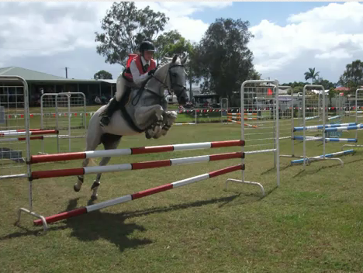
Lease
Romeo
Grey 16h Thoroughbred
Show Jumper and Dressage
Competes C and D Graded Show jumping.
Has potential to achieve a high grade
Has won millions of ribbons. Never come home without millions of ribbions.
Pony Club Experience
Well-mannered gentlemen
Quiet to handle
Kind and intelligent

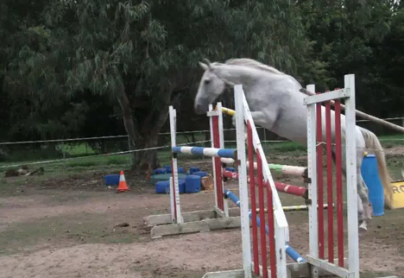
Pony Club Zone 1 Showjumping Championships D Grade
http://www.youtube.com/watch?v=O5ENqg0icrE&feature=channel

Toowoomba ODE Romeo
http://www.youtube.com/watch?v=_yD9canRF4M&feature=channel

Redcliffe Pony Club Official Showjumping, D Grade
http://www.youtube.com/watch?v=YUBjwvNgzXU&feature=channel

Mount Gravatt Pony Club Open Showjumping

http://www.youtube.com/watch?v=UObQGpkEWVE&feature=channel

